Group Task 3: Module 3
Machine learning: Concepts, Algorithms and Application
Build a Simple ML Process Flow: Groups create a complete flowchart for a machine learning project, covering data collection, feature extraction, algorithm selection, training, testing, and evaluation.
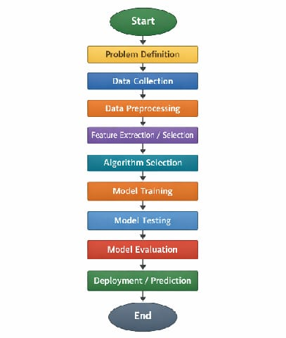

Here is the transcription of your notes with spelling and grammatical corrections to make them more meaningful, while keeping the original structure intact.
​1. Problem Definition
- ​Clearly define what you want to predict or classify.
- ​Define what problem you are solving.
- ​Identify whether it is Classification, Regression, or Clustering.
- ​Decide success criteria:
- ​Identify the business or real-world problem.
- ​Example: Predict house prices; detect spam email.

​2. Data Collection
- ​Gather raw data from different sources.
- ​Ensure data is relevant to the problem.
- ​Collect sufficient quality of data.
- ​Identify structured and unstructured data.
- ​Check data permissions and privacy rules.
- ​Example: House size, location, no. of rooms.

​3. Data Processing
- ​Clean the data.
- ​Handle missing values, remove duplicates.
- ​Convert text/categorical data to numbers.
- ​Normalize or scale numerical values.
- ​Remove outliers.
- ​Example: Replace missing price with average value.

​4. Feature Extraction/Selection
- ​Choose important input for the model.
- ​Remove unnecessary data to improve accuracy.
- ​Creating new useful features from raw data (feature engineering).
- ​Choosing only important features.
- ​Example: Select area and location as key features.

5. Algorithm Selection
- ​Choose an ML algorithm based on the problem type.
- ​Classification: Decision Tree, SVM.
- ​Regression: Linear Regression.
- ​Factors to consider: size of data, speed required, accuracy needed.
- ​Example: Linear Regression for price prediction.

​6. Model Training
- ​Feed training data to the algorithm.
- ​The model learns patterns from the data.
- ​Data is divided into training and testing sets.
- ​The algorithm learns patterns from training data.
- ​Learn relationship between input and output.
- ​Model adjusts parameters.
- ​Example: Learning correlation between area and price.

​7. Model Testing
- ​Test the trained model using unseen data.
- ​Check how well the model performs.
- ​Testing checks model performance on unseen data (use test dataset).
- ​Compare predicted output with actual output.
- ​Example: Predict price for new houses.

​8. Model Evaluation
- ​Measure performance using metrics.
- ​Accuracy, Precision, Recall, RMSE.
- ​For Regression: Mean Absolute Error (MAE), Mean Squared Error (MSE).
- ​Example: 90% accuracy in predictions.
​9. Deployment / Prediction
- ​Use the trained model in real-world applications.
- ​Model gives output for new inputs.
- ​Integrate into website or app.
- ​Monitor performance continuously.
- ​Update model when new data arrives.
- ​Use AI in cloud service.
- ​Example: Website showing predicted house price.

